

For all YOUNG MISSES Cond esending

A Moderne

H O U S E - K E E P I N G

Being

An A C C O M P T diverting and Wonder-full of a House Well-Kept by a Curiu{ Guest come two Year{ before Now: An Un-Naturral ' S P Y R I T ' of Dimension Unplumbed and Providense Convenient: Who Apparated From No-whereabout{ & Installed him-{elf within a {mall F I S U R E of the Kitchen Wall thu{ -
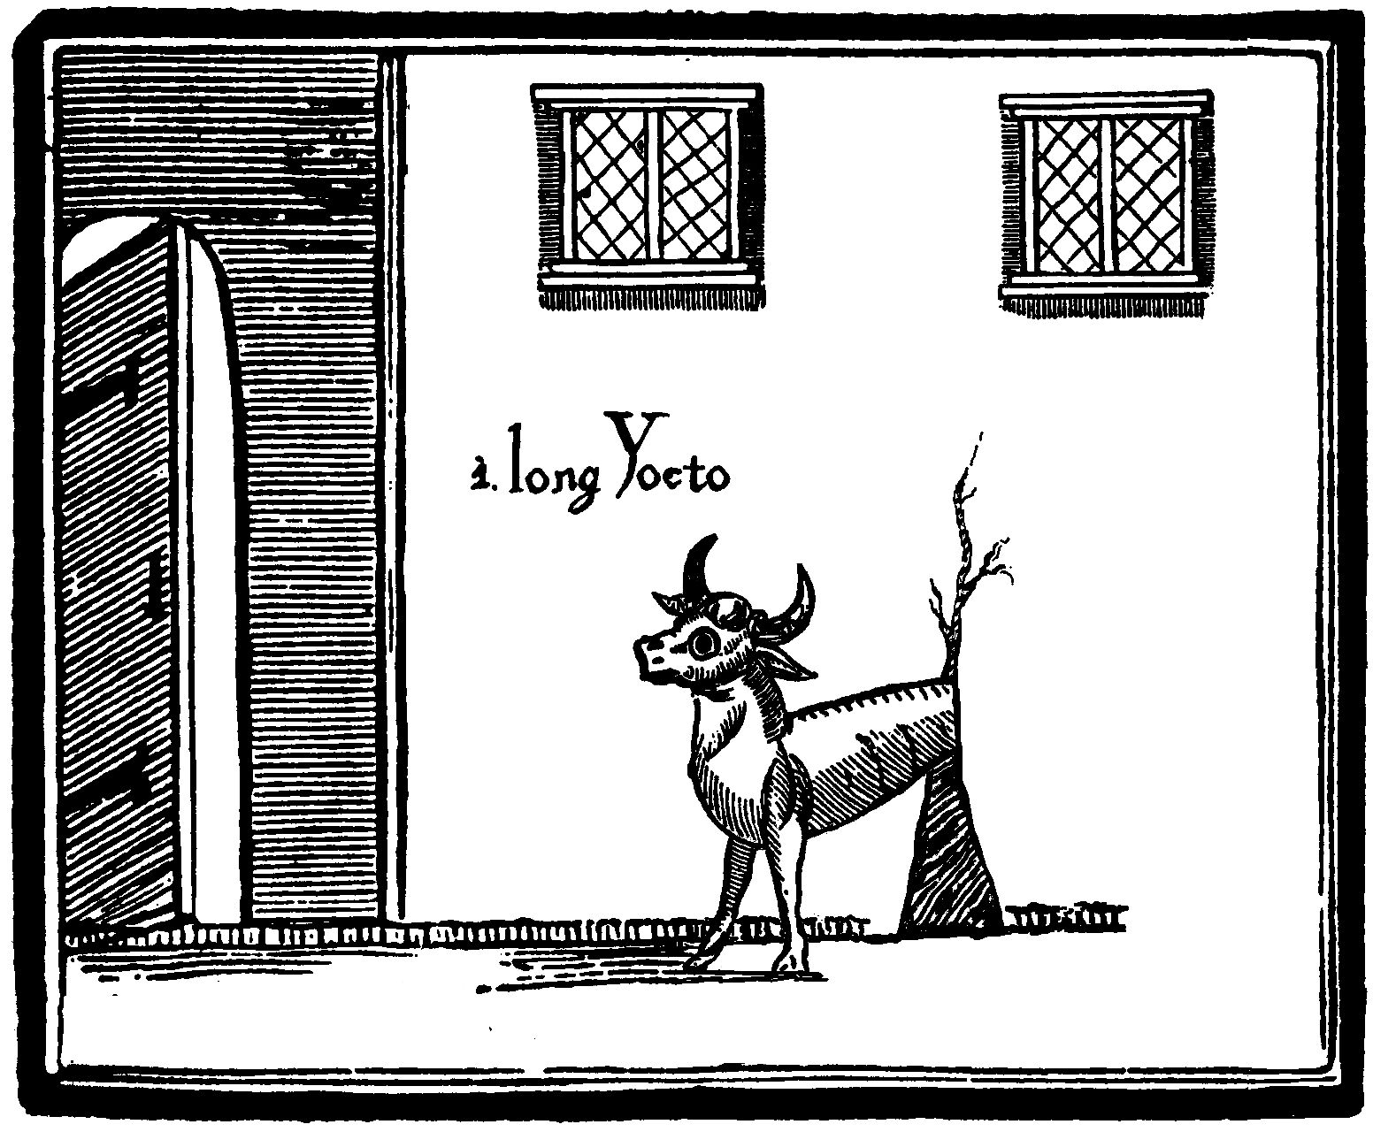

A{ here Re-told by the Propryetor and thu{ that S P Y R I T S mistre{{: one Anne Latch: a Seere{{ now much-trafficked and Feared in thi{ Country a{ -

'TH E W Y F E O F N I G H TH E A D'

(Formerly of the Place of that Name: being a Hamlet lying Newly by the Margent of the River Night: high upon the lone & Secrit M O O RS beyond the Di{trickt of Nighcester Town: in the Citie of Sheffield: within the county{ of York{. & Derby{.) -

Received at the Premi{e of the P U BLI SH E R {ome Day{ after her most Publick & Re-marked V A N I SH M E N T & being in Two Portion{: firstly, being the Dread REVELLATION & TESTAMENT (only Improved from her own Naturall re-Mark{ a{ to make of it In-telligent) of the Famed Secuel{ and Affair{ of her Un-credible Life these Two Year{ Past, from Nadir to Apojee viz.


Her past employ at the Knole Factory as Carder & Drudge; The Discovery of the 'Spyrit' & its Binding in Compack; Their Intercourse; The Abandonment Of Her Station; A Charitable Edukation; The Profit of Her Busyness as Doctress & Soilwarp; The Envies of all other Skryers, Physicks, Nigromancers, Girdlers and Tellers of Toad Dooms; Her Succour to the Miseries of the Be-nighted; Her Consort to the Preoccupations of Fine Folk & Their Rarer Climes; The Prophecy of the Kings Death; The Sins Of The Father; A Husbands Ailing; The Loss of the Nighcester Regiment, & other Events at Quebeck in which she Interfered; The Death Of A Scrumper; A Vengeful Ritual & A Most Mysterious Burgling; Rumours of Sodomy, Murder; A Trial That Be-witched A County; The Theft of A Guinea; Two Ropes Upon A Beam Borne &c.

A Curiou{ T A L E Yet More Marvellou{ in Being Received Addres{ed in Corespondence Implicit To TH E E alone: a young Woman of the City (F O R E – DR EA MT by the Wyfe her-{elf) who {eek{ in her Idle Youth {ome fre{h Venture, Novele Impulse or un-common new S T AT I O N for her Life -



AN D A L L - S O

In the Second Portion {erving a{ the Wyfe'{ Final W I LL & DOW AG E (Entrusted unto thi{ Publisher) Pa{{ed to T H EE in Invitation, To A{{ume Presidency over that Powerful & Inexhaustible S P Y RI T: who doe{ yet Lye Stationary At Hi{ L A IR within that Kitchen, Bound withyn a Circle Chalked & Begging {ome new M I S TR E SS to serve-

To be Guided by Exact adherence to the O C CU L TED K NO W LE DGE & In{truction{ here Advertized, & garnered by the Wyfe through much Application & Study; Arranged in {ome three hundred RE C EI PTS for every Aplication of a good Life, & recuiring no Bruti{hne{{ nor Ingenuity; yet only {oft and Fleeting touche{, movement{ P R EC I SE & other Libertie{ of your Province, to aid in the varied Manufecture of -
Orisons; The Chymick of Poultises & Chrisms; Charms; Cures; The Geolocation Of Husbands; Eternal Happiness; New Theories Of Worldly Matters; Sibyls; Decouzenings; The Subduction Of Base Natures; Parties; Druggs; Auguries; Riches; Wardings; Sidereals; Tricks & Entertainments; Weightlessnesses; Spells Of Love; Beauty Eternal; The Edukation of the Sex; Demonstrations; Fresh Questings; The Smiting Of Suitors; Such Powers; Frictionalities; Rare Freedoms; Rustick Wisdoms; The Creations Of Panaceas Without Gnosticks; The Manipulation Of Natural Geniuses; Nostrums; Vengeances of Gender; The Regard Of The County &c.

Added To This Generous Packett IN H E R I T EN T OF PRICE:

The D EE DS & free-holding of the famed Residence and Lands of the Wyfe of Nighthead; signed into your Good name and lying only some days Repair from thence by Sedan;

A tabulated A L MAN ACK and Kalendrical of the Spyrits Lunations, Perigees & all DATAS of Remark; and Accurate to every Week of every Year Hense;

The Much-Copied Amuletts, Generated by the Wyfe & her S P Y RI T, for every Remedy; printed upon an Auspicious & Ex-clusive P AR C H M E NT, Received of the Sheffield Assizes (said to make them Efficacious), and to be Cutt Free & Kept;

A Mementoed Edition of that Well-Loved New Ballad called 'The Warmth Without The Fyre' &c.

S H E F F I E L D:
Printed for your Fancies Solely by Mr. William Cryer
of the Company of Stationers
above the signe of the Delphin upon Balm Green without-Far-Gate

MDCCLX

To be Solde by all goodly Markets and Vendors
or for Subscryption by Cart to Mr Chapman of Bower Ln.
[ 3s 6d when Bound ]

